Know where to go for help, advice and support!

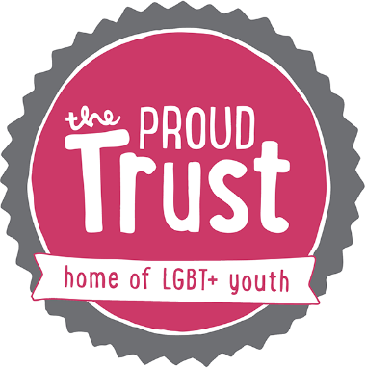
https://www.theproudtrust.org/young-people/
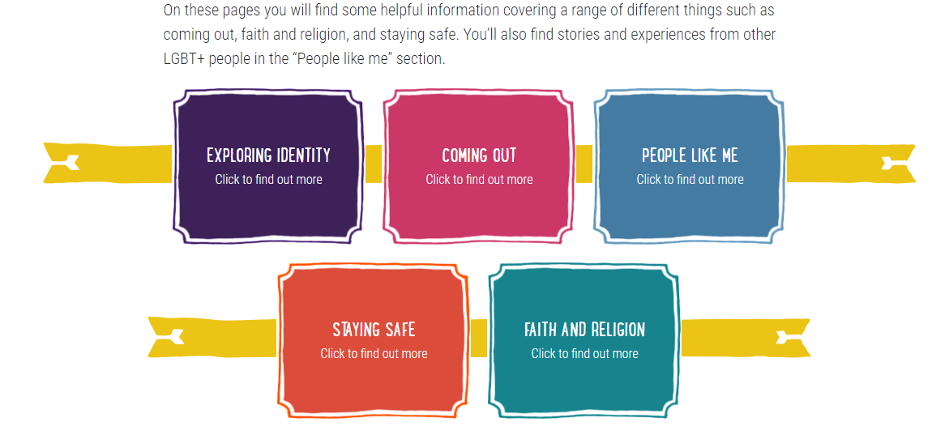
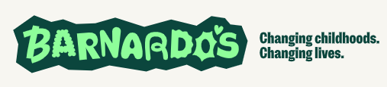
https://www.barnardos.org.uk/get-support/support-for-young-people/lgbt


